9. AZURE DEV OPS OR CI CD PIPELINES

AZURE
DEVELOPMENT
OPERATION

OR

CONTINUOUS INTEGRATION
CONTINUOUS DEPLOYMENT

- INTRODUCTION

- Dev Ops is a culture.
- It is a combination of Development and Operations teams working together.
- Goal : to fasten the SDLC (Software Development Life Cycle) process.

- Traditional Project Flow : Project Start
- Plan Phase
  - Activities : Requirement gathering, Design, Planning
  - Done by: Business Owner, Product Owner
- Development Phase
  - Activities: Programming the code, Compile the code, Build, Test, Packaging, Generate .war / .jar files
  - Responsible Team: Development Team
- Infrastructure (Infra) Phase :
  - Activities: Storage setup, Network setup, Server setup, Deploy .war file on server

- DevOps Culture (Modern Approach)
- Combined Responsibility : Development + Infrastructure handled by DevOps Team
- DevOps Responsibilities : Build the code, Unit testing, Packaging, Artifacts publishing, Code quality check, Image scanning, Security, Infrastructure setup, Deployment, Monitoring, Configuration Management

- Methodologies :
- Waterfall Methodology :
  - Work is done phase by phase
  - Flow: Top → Bottom
- Top Phase : Gather all requirements first, Start development after complete planning, Takes years
- Bottom Phase : Final delivery

- Agile Methodology
- Modularization : Project is divided into modules, Enables parallel development
- Modules & Teams : Each module has its own team
- Example: Module 1 → 1–100 work items, Module 2 → 1–100 work items
- Iterations (Sprints) : Work is done in iterations called sprints (scheduled)
- Example: 1st Sprint (Jan 1 – Jan 30), All 4 modules → work items 1–50
2nd Sprint (Feb 1 – Feb 28), Remaining work items
- Backlog : If work is not completed in a sprint → called Backlog Items
- SDLC in Agile : Each module goes through full SDLC process
- Final Stage: UAT (User Acceptance Testing)
- Done by : Users, Clients
- Flow : UAT → Testing → Bug → Sprint → SDLC → UAT

- SDLC Process (Detailed Flow)
- Development Flow : Developer → Version Control → Build → Test → Package → Quality Check
- Tools Involved : Version Control: Git,
  - Build Tool : Maven,
  - Code Quality: SonarQube

- Continuous Integration (CI)
  - Steps : Code commit, Compile & build, Unit testing, Packaging, Code quality check
- This process is called Continuous Integration

- Infrastructure & Deployment
- Environment Setup : Storage, Network, Servers: Dev, UAT, Prod
- Monitoring & Tools : Prometheus, Azure Monitor, ELK Stack
- Configuration Management : Ansible
- Continuous Deployment / Delivery
  - Includes : Infrastructure setup, Deployment, Monitoring, Configuration management
- This process is called : Continuous Deployment / Continuous Delivery

- Azure DevOps – Service Types
- Azure DevOps as IaaS (Infrastructure as a Service)
- Azure provides only Virtual Machines (VMs).
- You must : Install DevOps tools manually, Configure everything, Set up until project/page management
- User is fully responsible for setup and maintenance.

- Azure DevOps as SaaS (Software as a Service)
- Platform provided: Azure DevOps
- Access via: dev.azure.com
- No installation required.
- Microsoft manages : Infrastructure, Setup, Maintenance
- Users directly use DevOps features (repos, pipelines, boards, etc.)

- Azure Account & DevOps Access
- Azure Free Trial Account
- Azure Free Trial account → Azure DevOps account gets disabled
  - Limitation exists when using free trial for DevOps

- Azure Pay-As-You-Go Account
- Azure account upgraded to Pay-As-You-Go
- Azure DevOps becomes available with free usage tier

- CI/CD Pipelines
- Pipeline Execution : CI/CD pipelines are used to trigger processes automatically.
- Pipelines can run : In cloud environments, In on-premises environments

- Use Azure Free Trial account for general Azure services
- Convert old Azure account to : Pay-As-You-Go
- Then : Link Azure DevOps with this account

- Simply :
- DevOps = Culture + Automation + Collaboration
- Waterfall = Sequential (slow)
- Agile = Iterative + Fast
- CI = Build + Test + Package
- CD = Deploy + Monitor + Maintain
- IaaS → You install & manage DevOps
- SaaS → Azure DevOps (dev.azure.com) is ready to use
- Pipelines → Trigger CI/CD in cloud or on-prem
- Free Trial → DevOps limitations
- Pay-As-You-Go → Better for DevOps usage

- OPENING AND CREATING AZURE DEV OPS ACCOUNT

- In search bar type : azure devops

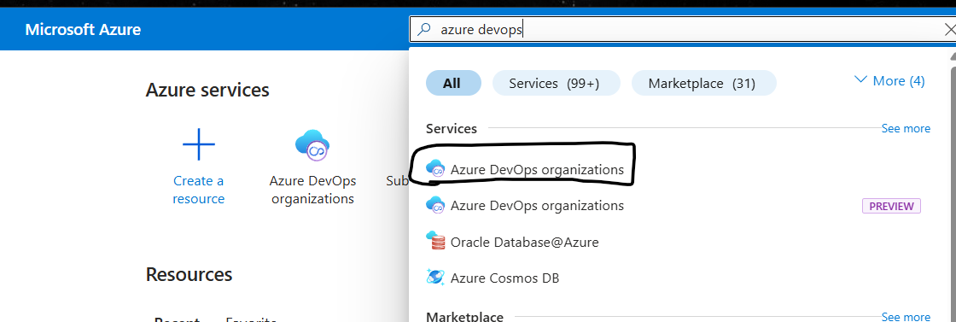

- Account creation steps :
- For 1st time it shows as create organization :
- Continue -> enter organization name, region, subscription
- Organization name is your wish
- Once it is created
- Browse for azure parallelism request : https://aka.ms/azpipelines-parallelism-request
- Fill then form and submit

Top Level : Organization -> projects

View Organization
In azure dev ops we have
Board project planning boards : agile methodology
Repository : version control
Pipelines : classic editor or yaml
Classic editor :
Pipelines : ci
Release : CD
Yaml : using --- or document saparator we write ci and cd

Test cases : done by testing team
Artifacts : all dependencies you can store (package, dependencies )

Under overview ->
Dashboards : for widget and assigned work
Wiki : we can store projects ( actually used share point and confluence )
Confluence : for project documents

Pipelines :
For Microsoft hosted agent : 1800 mins
Self hosted agent : 1 machine

Users :
Basic Free : 5
More than 5 users billed

Artifacts :
Basic free data : 2GB free
More than 2GB it is billed
We will use below 20MB

- Organization settings :
- Overview : We can check overview details as
Name
Name privacy url
Organization limit :
Project limit : 1000 and
Work item tag limits : 1,50,000

- Projects : we can add and check projects

- Users : We can add users either microsoft or Microsoft AD users or gmail
once we add users, we can move to particular projects

- Billing :
MS Hosted or CICD : 1800 min
Self Hosted CICD : 1
Test Plans and test cases 1 month free
Artifacts : 2GB free

- Global Notifications : when ever a project complete or getting errors
they will not login to CICD they get notified and check

- Usage : Shows done all the work by user

- Extensions : 3rd party tools or plugins for projects

- Microsoft Entra : like active directory
all domain users will be integrated

- Security Over View
- Security Over view : who is having which permissions
which group is having which users and permissions according to that

Few options will be in disable mode
We need to enable it from organization settings

- Project settings
- General :
  - Over View : project options like boards, repos, pipelines, test plans, artifacts enable
Project Usage limit :
Teams : 5000, Dashboards : 500, Delivery Plans : 1500, Area : 10,000, Iterations : 10,000
  - Permissions : according to groups and users permissions provided
  - Notifications : Which team completed which task notified by email etc
  - Service Hooks : for 3rd party tools
  - Dash Boards : enable or disable create, edit and delete

- Boards
  - Project configuration : to add or delete and modify sprints
  - Team configuration : daily tasks and daily works
  - Github Connections : Github repo also be used

- Create Project
- In repo -> files
on top you can find option like create repo import repo and manage repo
click on create for creating a repo
click on import for importing from github

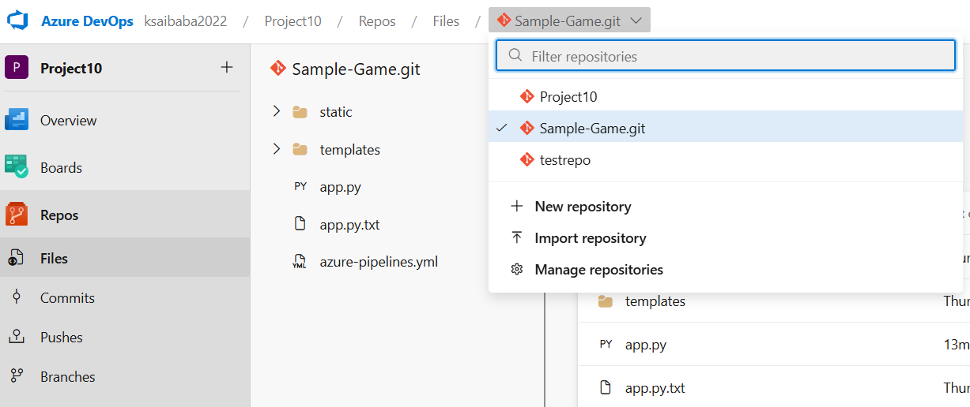

Task 1 : Create infra using terraform in cicd

- Pipelines : release
- add an artifact :
  - source type : if already in dev repo select azure repo
  - project :
  - source repo :
  - default branch :
  - default version :
- stage 2 : add stage : empty job : just change name as deploy ( click on close)
  - display name : agent job
  - agent pool : azure pipelines
  - agent specification : windows 2022
- + or add job : terraform tool
  - Add Terraform :
    - Version : 4,
    - Provider : azurerm
    - Command : init
    - Configuration directory : select where is folder or repo

For init, plan, apply follow these steps
For azure to cloud connection connection here : azure backend service connection : sub name
If new authorize it using credentials
Resource group : select rg
Storage account : select it
Container name : select it
Key : add the key from storage account key to connect
Provide storage account details to store infra details

- Now save it
- Click on Create Release
- Deploy it

3 SELF HOSTED AGENT

Two types of agent :
MS agent : is setup and managed by MS, OS can be windows, linux mac
Self hosted agent : it is setup and managed on owr own, OS can windows, linux, mac, docker container

- For triggering a pipe lines
- Trigger -> stages -> in each stage jobs are present.
- Agents make sure jobs are running
- In each job Task -> steps -> scripts
- Trigger can be manually or automatic

- For creating self hosted agent
- Project settings -> pipelines -> agent pools
- Add pool ->
  - Pool type : self hosted
  - Name : any
  - Create
- Click on pool created
  - Click on agent -> new agent -> depends on OS follow steps
  - Any OS using link download link paste in web browser and download
  - If windows :
    - Extract it in c folder create a agent folder and to it,
    - Now from folder open cmd, and enter .\config.cmd
  - If linux :
    - Enter : ./config.sh
  - Now it asks for server url
  - Click on organization settings -> General -> overview and copy url under name
  - Enter url present in azure dev ops
  - Next authentication type : just click enter
  - For PAT click on azure dev ops organization settings

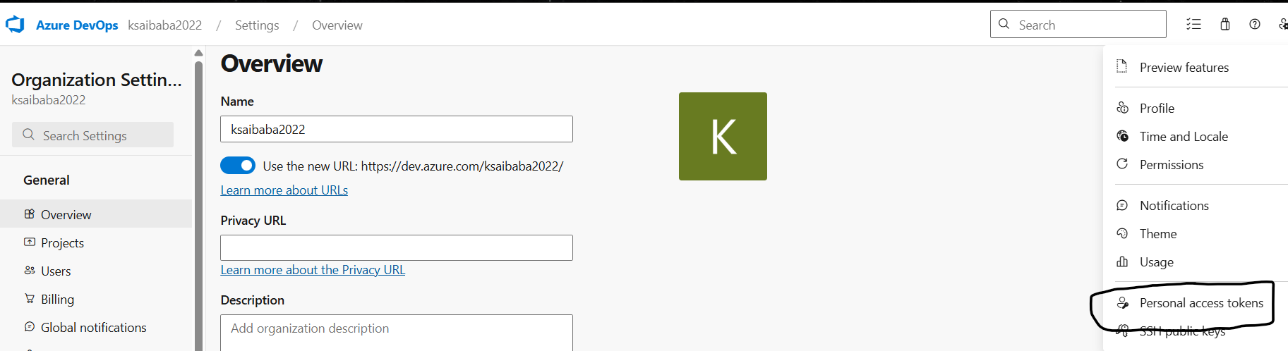

- Create a token :
    - Name: anything , organization: select any one, expiry : 30 days
    - Click on Create : copy token and paste it

  - Enter agent pool : copy paste agent pool name from organization settings -> pipelines -> agent pools : copy name and paste
  - Enter agent name : click on agent pool -> agent copy name and paste it
  - Enter work folder : just click on enter
  - Enter user account to use service : enter button
  - Run agent as service : yes
  - Just click enter
  - Agent created,
  - Type : ./run.sh ( else agent wont come online )
  - just for few time and wait for agent online

- Create a storage account in azure

- Create a pipelines -> select classic editor
  - Select source : repo or git
  - Team project : select project
  - Repository name : select repo
  - Branch : select branch
  - Continue
- Empty job :
- Now it shows the MS agent,
we can change to self created agent
- Step 1 copy files
task version : 2*
Source folder : vm build
Target folder : copy paste from hint indication
- Step2 publish artifacts
Step1 source folder step2 directory must be same
artifact name : anything

# in CI artifacts should be published mandatory

- Save and queue, save and run

- Pipelines
- Release : new release pipeline
- Add an artifact :
  - Source : build
  - Project : select project
  - Source : project
  - Source alias : added
- Add a stage : empty job
  - Name : any name
  - Agent : own agent
  - Agent job : add task : terraform install
  - Terraform commands :
  - Configuration directory : source folder
  - Azure backend service configuration : click on manage
    - New service connection : ARM ( azure resource manager )
    - Identity type : app register or managed identity
    - Credential : secret
    - Sub id, sub name, tenant id and client secret
use azure entra id and create an app and provide permissions
    - Service connection name : anything
    - Provide access permission to all pipelines
  - Select service connection, RG name, storage name, container name, key,
- Provide steps for terraform validate, plan and apply

4. TERRAFORM DEPLOYMENT USING YAML

$(build.artifactsagingdirectory)
Self hosted agent :
CI :

Source : agent\_work\1\s
Target : Agent\_work\1\a

CD : r1\a\
Tool
Task

Until before done using classic editor
Pipeline : CI
Release : CD

Now in yaml file we do both CI and CD

Key value pairs
Yaml validator and yaml lint

Ex : Any.yaml file
person: #dictionary
name: Sai # key value pairs
city: Hyderabad # key value pairs
occupation: Devops # key value pairs
hobbies: # list
- carrom
- chess
friend: # multi list
- name: friend1
city: Hyderabad

while writing yaml files we need to know yaml file hierarchy or yaml structure

- Check which repo has your project
- New pipeline -> azure repo git (YAML) -> select repo which has project
starter pipeline ->

This yaml script is fixed universal :
trigger: none
stages:
- stage: 'build_stage'
displayName: 'build and publish'
jobs:
- job: 'publish'
displayName: 'package and publish job'
pool:
vmImage: ubuntu-latest

in yaml we can use assistance also
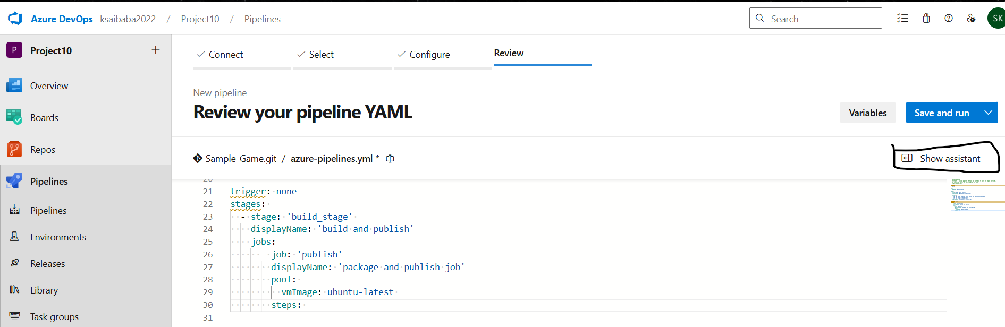

Type any word and it shows options
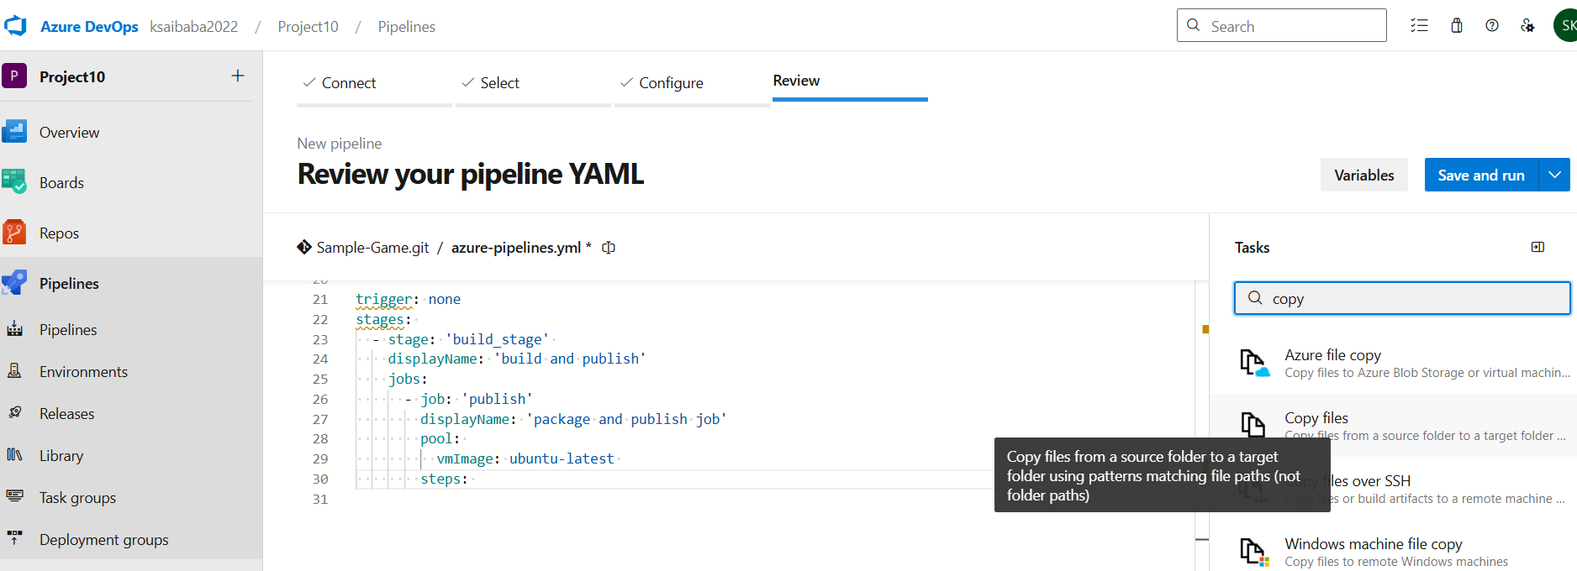

Select copy files
Type source and target folder :
Source folder : VM-Build
Target folder : $(build.artifactstagingdirectory)

Now click on add
Now same again type publish pipeline artifacts

Code must be this way :

trigger: none
stages:
- stage: 'build_stage'
displayName: 'build and publish'
jobs:
- job: 'publish'
displayName: 'package and publish job'
pool:
vmImage: ubuntu-latest
steps:
- task: CopyFiles@2
inputs:
SourceFolder: 'VM-Build'
Contents: '**'
TargetFolder: '$(build.artifactstagingdirectory)'
- task: PublishPipelineArtifact@1
inputs:
targetPath: '$(build.artifactstagingdirectory)'
artifact: 'drop'
publishLocation: 'pipeline'

completing the script, save and run, again save and run

Now CD – Continous Deployment
Create a storage account for storing statefile of infra
Now use show assistant for terraform init, validate, plan, apply
Use self host for service connection

$(Agent.BuildDirectory)/drop
path is a conventional location in Azure DevOps pipelines used to store build artifacts (like binaries, packages, or ZIP files) before publishing,
Corresponding to $(Pipeline.Workspace)/drop.
It is frequently used in tasks to output, copy, or publish artifacts.
$(Agent.BuildDirectory) is the local path on the agent where all folders for a specific build pipeline are created.

Now run pipeline,

We can configure pipelines using yaml also and reusability.

Task: we need to do the task using self host agent with same yaml file

Since we have done manually CI, now pipeline can be done automatic

In tasks use hosted machine as MS pool and machine
- Triggers
- Enable continuous integration
Select git branch also for triggering
which branch is selected if we push to that only trigger happens else not
- We can add branches also
- We can add schedule with time

- For continuous deployment
- Release -> edit -> click on current symbol and enable continuous deployment trigger
- So when artifacts get published, artifacts get called and trigger process
- For every time we don’t want deployment
- So we use approvals so when approved only deployments start else no
- We can also clone for multiple stages
- And for deployment we can use manual or automatic

Java app :
Maven : .war
Dockerfile -> image
Kubernetes /appservice

5. CI CD END TO END PROJECT

Java code

Maven build
Sonarcube
Docker
trivy

deploy this in Kubernetes

self hosted machine : linux

Trivy : scans the image for security
Linux machine -> agent
Java for java code
maven for build engine
docker for image conversion

sonarcube image and will create container for that

- Create vm and login
- Update it and install java, maven, docker,
- Install sonarcube on docker container using image : mc1arke/sonarqube-with-community-branch-plugin
- Command : docker run -d --name sonar -p 9000:9000 mc1arke/sonarqube-with-community-branch-plugin
- Now browse ip:9000 for sonarcube for scanning code and checking
- In azure devops create a new project new repo and push code into it
- In project settings -> pipelines -> agent pools -> new pool,
- Create a self hosted agent using VM
- While creating agent : create PAT,
- Copy url, agent pool name,
- Type: ./run.sh
- Select agent and click on capability
- Click on add new capability
Name : java
Value : true

Name : maven
Value : true

- Create pipeline -> classic editor -> azure repo git
  - 1st task : add maven
  - 2nd task : copy files
  - 3rd task : publish pipeline artifact
  - Save and queue
  - Search sonar : add prepare analysis on sonar server
  - Next step : run code analysis
  - Command line script
  - Build and push : docker
  - Command line script
  - Run pipeline

6. END TO END PROJECT CICD

- Create vm and install java, maven , docker
- Download new agent link and create self host agent
- Pipeline -> classic editor -> azure repos git -> select self host agent
- Tasks : maven pom.xml
  - Copy files from source : $(system.defaultworkingdirectory), dest or target : $(build.artifactsstagingdirectory)
contents : **/*jar
deployment-service.yaml
  - Publish pipeline artifacts : file or directory path : $(build.artifactsstagingdirectory)
  - Docker build and push : create new connection for docker hub

- In release :
- Agent job : select the self hosted agent
- Steps : install kubectl latest
  - Kubectl apply
  - Save

7. NODE JS + MONGO DB APP DEPLOY TO AZURE APP SERVICE

Create app service
Create a vm for self hosted agent
Create a project in azure devops
Create a self hosted agent (grant access permissions to all )
Create a repo -> upload files
Create a pipeline classic -> azure repo git -> empty job
In agent machine self hosted agent
- Steps : use node 20
- Npm ( for installing dependencies )
- Copy files : source : $(Build.SourceDirectory)
Dest : $(build.artifactsstagingdirectory)
- Archivefiles ( for zipping ) source : $(build.artifactsstagingdirectory)
dest : $(build.artifactsstagingdirectory)/output.zip
- Publish pipeline artifact
Run this

- Pipelines -> release ->
- Build : add artifact
source type : build -> select source -> add
- Add a stage : empty job
- Add azure app service manager
- Select subscription, app service type, app service name, package or folder
  - Run time stack : node 18
- Startup command : cd a && npm start
- Save and release

8. AZURE BOARDS

For Project planning we will create azure projects
We need to have idea on which methodology we are using
For ex if we developer working or assigned tasks on agile methodology
We should also have agile methodology else we are not doing project correctly

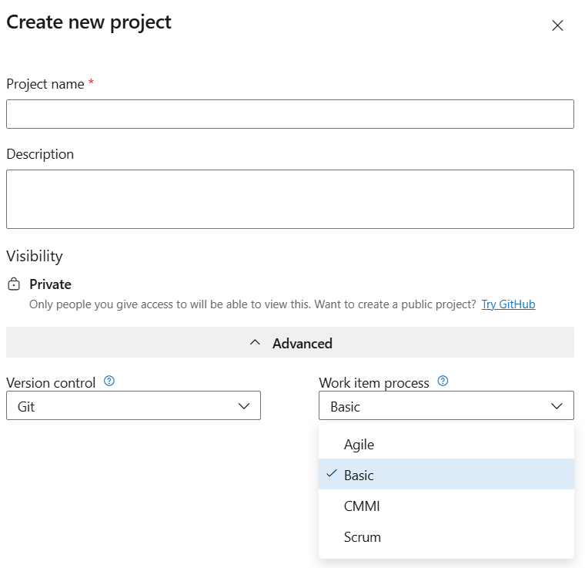

Depends on process boards options get changed

Basic : choose basic when your team wants the simplest tasks, and Epics to track work

Use epics to track significant features or equipments
Use issues to tracks user stories bugs or other smaller items of work
Use tasks to track even smaller amounts of work for which you want to track time either in hours a day

Portfolio backlog – epic
|
Product backlog -> issue
|
-> task

For completing a project Boards are very important
We can find what is issue, is issue resolved or not, if yes what is next, if no why no

Majority boards are used by development team

Agile :
Use epics to track significant business initiatives
Use features to track specific applications or set of work
Define user stories to track work that you’ll assign to specific team members and bugs to track code defects
Lastly use tasks to track even smaller amounts of work for which you want to track time either in hours or days

Scrum – just name changes everything is same

CMMI ( Capability Maturity Model Integration )
Epics and features are used to group work under larger scenarios
Requirements and tasks are used to track work
Bugs track code defects

In project for any changes we want to do, or we need to do
Or we should do at last for rebooting system if system is stuck
If we do any work in 2 hours it need to be completed in 2hours
Else not in 2 hours what is alternate
For every thing we need to raise CR – change request
If does not raised then its escalation

Work items :
You can use work items to track everything you need to track
Each work item represents an object stored in the work item data store
Each work item is based on a work item type and is assigned on identifier which is unique within an organization or project collection
Thw work item types available to you are based on the process used when your project was created ( Agile, Basic, Scrum, or CMMI )
You use different work items types (WIT) to track different types of info
Specific tools :
- Add backlog items such an issues (basic process), user stories (agile), product backlog items (scrum) requirements
- Define features and epics
- Define triage and manage bugs
- Add tasks to backlog items

1. Basic Process (Simple Projects)

Board Options:
- Epic → High-level feature or big requirement
- Issue → General work item (tasks, bugs, etc.)
- Task → Small unit of work to complete

Use:
- Best for small teams or beginners
- Keeps tracking simple without complexity

2. Agile Process (Flexible Development)

Board Options:
- Epic → Large business goal
- Feature → Functional part of an Epic
- User Story → Requirement from user perspective
- Task → Work needed to complete story
- Bug → Defect or issue
- Issue
- Test case

Use:
- Best for Agile/Scrum teams
- Focuses on customer requirements & iterations

3. Scrum Process (Sprint-based Work)

Board Options:
- Epic → Large initiative
- Feature → Part of Epic
- Product Backlog Item (PBI) → Main work item (requirement)
- Task → Work to complete PBI
- Bug → Defect

Use:
- Best for Scrum teams working in sprints
- Structured around backlog & sprint planning

4. CMMI Process (Process-heavy / Enterprise)

Board Options:
- Epic → Large business goal
- Feature → Functional component
- Requirement → Detailed requirement
- Task → Work to complete requirement
- Bug → Defect
- Change Request → Request to modify system
- Risk → Potential issue affecting project
- Review → Evaluation or audit work

Use:
- Best for large enterprises & compliance projects
- Supports documentation, audit, and control

Process | Complexity | Main Work Item
Basic | Low | Issue
Agile | Medium | User Story
Scrum | Medium | PBI
CMMI | High | Requirement

- Simple
Basic → Simple tracking
Agile → Flexible development
Scrum → Sprint-based work
CMMI → Enterprise-level control

there
- Organization settings -> general users

- For adding users : enter gmail or Microsoft mail
Later we can move to particular project

Global notifications :
When ever a developer complete code or gets any error
This trigger a error and manager will look after
They will login to it and verify

- Usage : it shows what are the things done by user
- Extension : 3rd party tools or installed to run pipelines

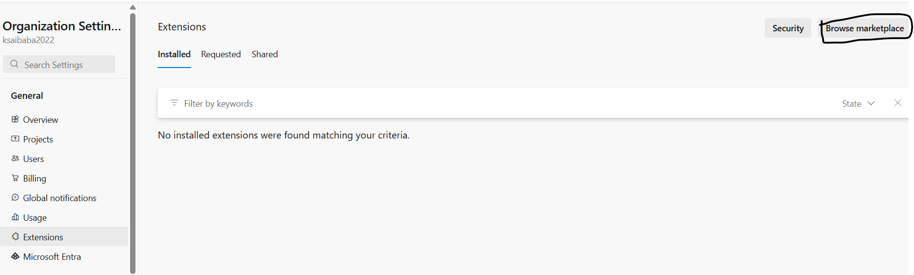

Click on market place and select required extension

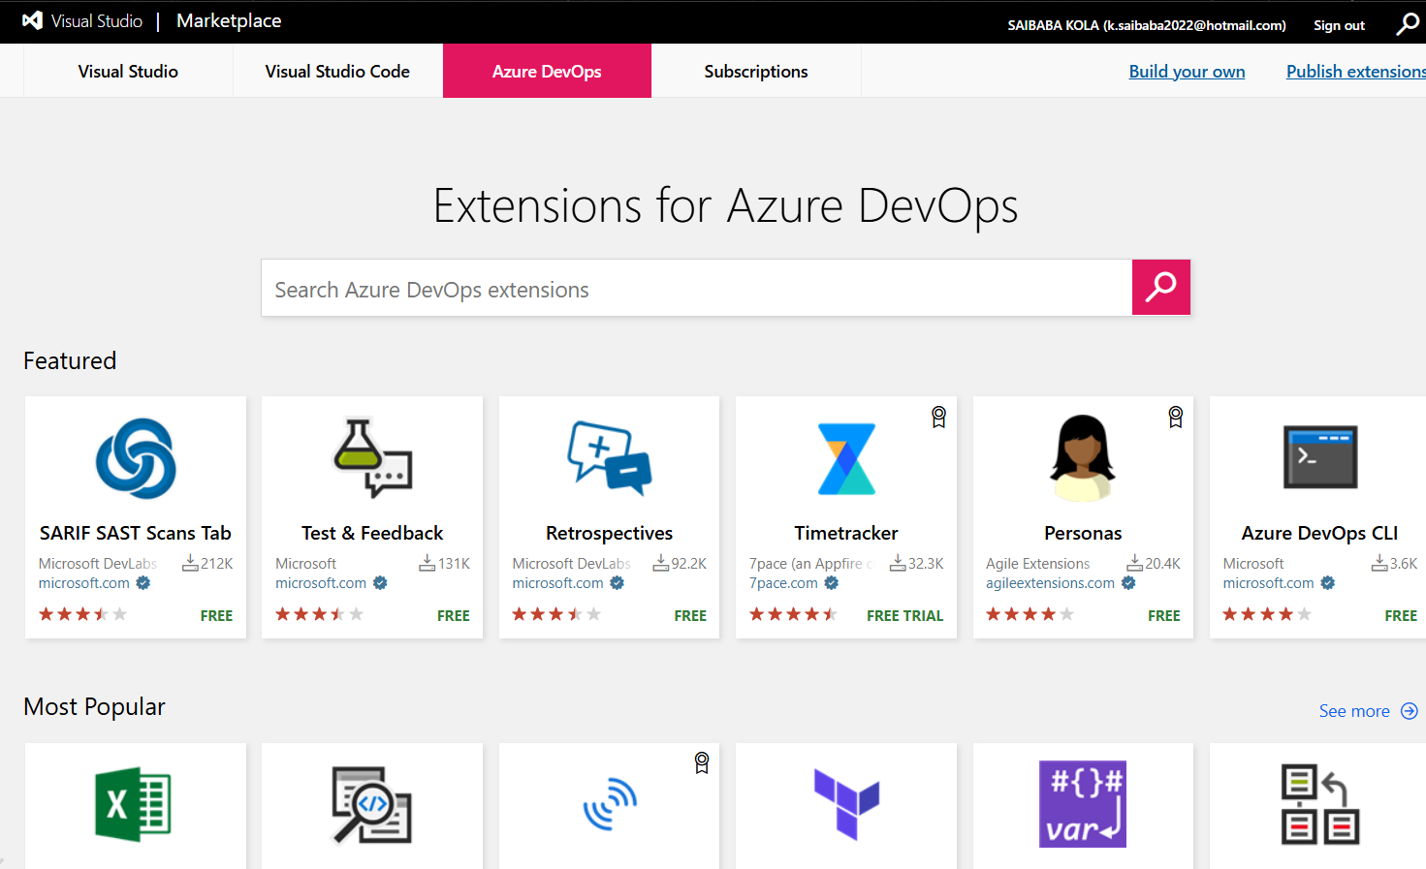

- Microsoft directory : if we have any azure active directory and created users
By clicking on connect directory we can connect it

- Security overview : provide access to users and check what access person has by clicking on repository
who is build admin, read, write etc

- Permissions : in a project which the user or person is according to group
they get permissions

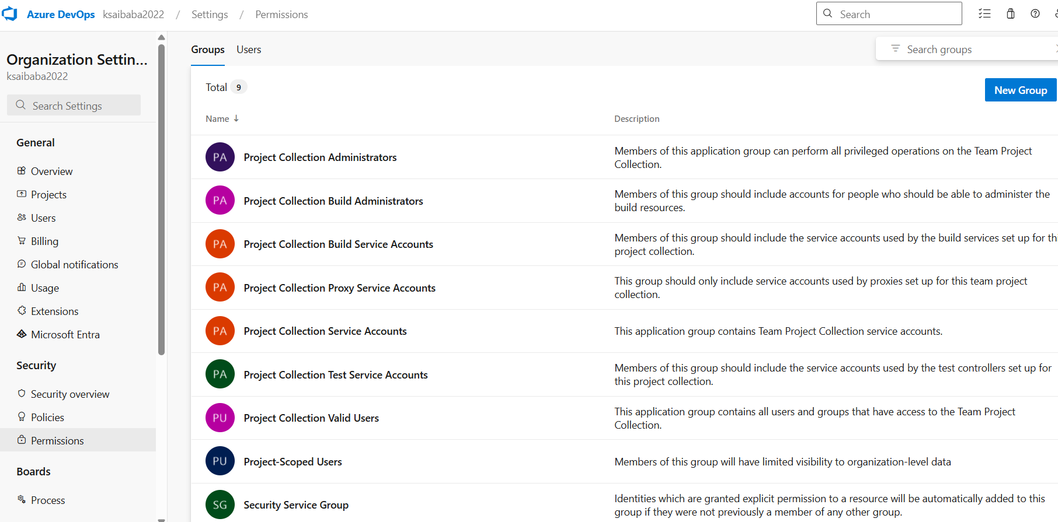

- Boards for project planning : for ticketing system
agile methodology,
How we work
Which process we follow
if issue raises which ticket we raise

CREATE A PROJECT

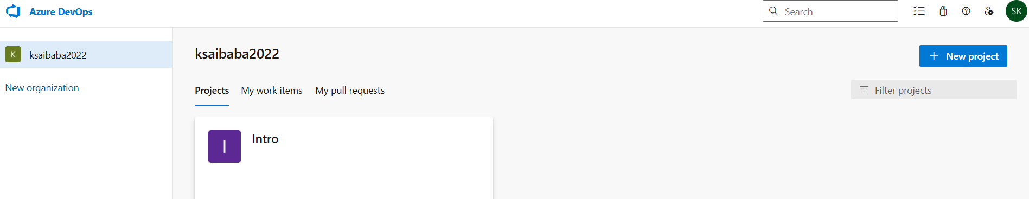

Click on new project
Project name : any word
Description : choice

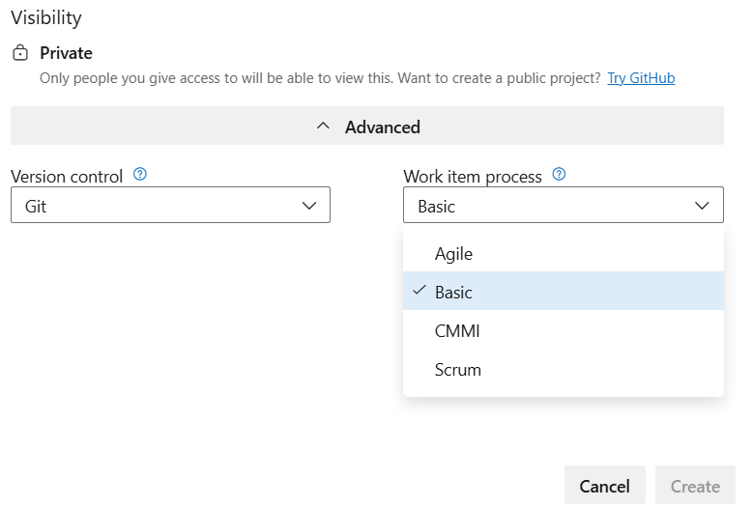

Version will be git
Work item process depends on project
Present we can use basic

Some options will be in disable mode
We need to enable it

- Start project:
- Create a repo -> project 10 -> create a repo
- After creating repo
- You will find Files -> clone
- Copy links and
- Open folder of local pc where you want to push code
- Push code using git and this link add in git
- While pushing it would ask Microsoft credentials

If you want to import from git hub
Copy github repo kink and paste in
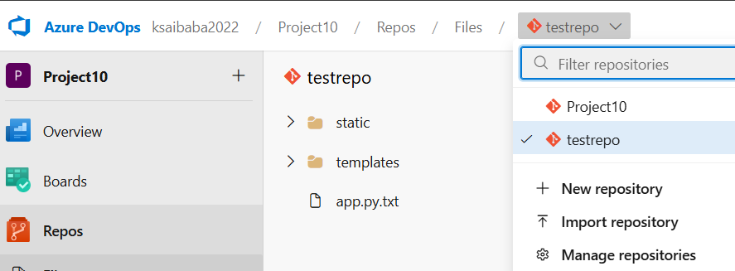
In import option

Terraform code -> build infra using cicd pipelines

Terraform -> version control - github -> build -> packaging -> artifacts

We need a agent to execute this jobs
We have 2 types of agent
1 Microsoft Hosted Agent : it is setup by Microsoft, OS< windows linux
2 Self Hosted Agent : it is setup and managed on our own, OS can be anything

Copy repo files to self host
Repo
Terraform install validate and commands

Copy files from Source -> Artifacts
Publish the arctifacts because CI output is CD input

If ci is not published then it wont appear or visible in cd

Using terraform we can perform directly cd

In cd we have agent machine

Using terraform create a vm in cloud

Now import project and vm code

In pipelines if it is disabled goto project settings -> pipelines settings and enable it
If no permission go to organization settings -> pipelines settings and enable it

- Pipelines
- Releases -> new pipelines
- Click on close and click on a add an artifact
- Add a source type
Select code availability
Project : project name
Source code : select where code is present
Default branch : select branch name
Leave version and source alias
Now click on add

- Select add stage -> empty job
Name : anything ( ex deploy )
Click on 0 task

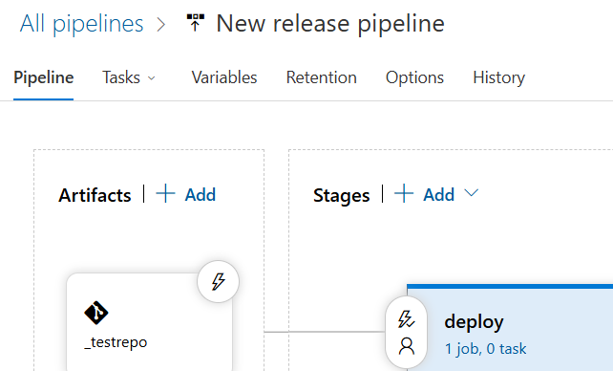

  - Tasks :
Agent pool : azure pipelines
Agent specification : windows 2022
On agent job click on +
Add terraform
If 1st time click on get it for free

Under agent job
Install terraform agent
Terraform : arurerm
Init
Plan apply

Create a release
Deploy
Click on logs to check what work is ongoing

